**DATA HIDING IN AN IMAGE USING COMBINATION OF STEGANOGRAPHY, CRYPTOGRAPHY  
AND TRANSMISSION**

**A Project Report**

*Submitted in partial fulfilment for the award of the degree*

*of*

**Master of Technology**

***in***

**Information Technology**

*by*

**BHUVANA CHANDRA PATHI**

**17MIN0618**

*Under the guidance of*

**Prof. Ravinder Reddy**

**Professor**

**VIT, Vellore.**





**School of Information Technology and Engineering**

Oct 2020.



**School of Information Technology and Engineering**

**DECLARATION BY THE CANDIDATE**

I hereby declare that the thesis entitled **“DATA HIDING IN AN IMAGE USING COMBINATION OF STEGANOGRAPHY, CRYPTOGRAPHY**

**AND TRANSMISSION”** submitted by me to Vellore Institute of Technology University Vellore, in partial fulfillment of the requirement for the award of the degree of **Master of Technology** in **Information Technology** is a record of bonafide project work carried out by me under the supervision of **Prof. Ravinder Reddy.**I further declare that the work reported in this project has not been submitted and will not be submitted, either in part or in full, for the award of any other degree or diploma in this institute or any other institute or university.

**Place**: Hyderabad Bhuvana Chandra Pathi

**Date**: 11/12/2020 **Signature of the Candidate**



**School of Information Technology and Engineering**

**BONAFIDE CERTIFICATE**

This is to certify that the project work entitled **“DATA HIDING IN AN IMAGE USING COMBINATION OF STEGANOGRAPHY, CRYPTOGRAPHY**

**AND TRANSMISSION** **”** by **BHUVANA CHADNRA PATHI (17MIN0618),** to Vellore Institute of Technology University, Vellore, in partial fulfillment of the requirement for the award of the degree of **Master of Technology** in **Information Technology**, is a project bonfires work carried out by her under my supervision. The project fulfills the requirement as per the regulations of this Institute and in my opinion meets the necessary standards for submission. The contents of this report have not been submitted and will not be submitted either in part or in full, for the award of any other degree or diploma in this Institute or any other Institute or University.

**Prof. Ravinder Reddy**

**Internal Supervisor**

**Professor**

**VIT University**

# **ABSTRACT**

Cryptography and Steganography are the two popular methods for secure data hiding and Transmission. Cryptography is the science of encrypting and decrypting data. Based On complex mathematics. While Steganography is the practice of hiding information within something that appears to be no information is hidden at all.

So, steganography (hiding information) and cryptography (protecting information)

Both methods have their advantages, Information hidden using steganographic techniques will not attempt to decrypt the information because intruder will have no idea that there is any hidden information. Whereas message encrypted using advanced Cryptographic encryption algorithms is very difficult to decrypt for an intruder.

Though Steganography provides good security. it can be combined with Cryptography for better confidentiality and security. “The primary purpose of this project is protecting confidential data that being transmitted in a network from counterattacks possibly by combining steganography and cryptography.”

Different private key cryptographic techniques are used to encrypt the data based on sensitivity. And Embed the cipher text of the secret message in the LSB (Least Significant Bit) for each pixel according to the odd/even distribution method.

And the hole project is made user friendly by, making use of a python web framework Django which is very secure. Django framework includes built-in model “Users” which allows to build authentication and authorization ("permission") for the system.

# **TABLE OF CONTENTS**

|  |  |  |
| --- | --- | --- |
| **CHAPTER NO.** | **TITLE** | **PAGE NO.** |
|  | **ABSTRACT** | 4 |
|  | **LIST OF FIGURES** | 6 |
|  | **LIST OF ABBREVIATIONS** | 7 |
|  |  |  |
| 1. | **INTRODUCTION** |  |
|  | 1.1 PROJECT PURPOSE | 8 |
|  | 1.2 PROJECT SCOPE | 10 |
|  | 1.3 DRAWBACKS OF EXISTING SYSTEM AND BENEFITS OF PROPOSED SYSTEM | 11 |
|  | 1.4 DEFINITIONS, ACRONYMS, AND ABBREVIATIONS | 11 |
|  | 1.5 PROJECT OVERVIEW | 11 |
|  | 1.6 EMBEDDING PROCESS, ALGORITHM, EXTRACTION PROCESS | 12-16 |
|  |  |  |
| 2. | **LITERATURE REVIEW** | 16-17 |
|  |  |  |
| 3. | **SYSTEM REQUIREMENT SPECIFICATION** |  |
|  | 3.1 Software Requirements | 18 |
|  | 3.2 Hardware Requirements | 18 |
|  |  |  |
| 4. | **SOFTWARE ENVIRONMENT** | 19 |
|  | 4.1 Python | 19 |
|  | 4.1.1 Pillow Module | 20 |
|  | 4.1.2 NumPy Module | 20 |
|  | 4.2 Django Framework | 21 |
|  | 4.3 Django ORM | 22 |
|  |  |  |
| 5. | **SYSTEM DESIGN** | 23 |
|  | 5.1 System Architecture | 23 |
|  | 5.2 UML Diagrams | 24 |
|  | 5.2.1 Use Case Diagram | 25 |
|  | 5.2.2 Class Diagram | 26 |
|  | 5.2.3 Sequence Diagram | 27 |
|  | 5.2.4 Data flow Diagram |  |
| 6. | **REFERENCES** | 28 |

# **LIST OF FIGURES**

|  |  |  |
| --- | --- | --- |
| **Figure No** | **Title** | **Page No** |
| Figure 1.5.1 | Embedding process | 14 |
| Figure 5.1 | High Level System Architecture | 23 |
| Figure 5.2.1 | Use Case Diagram for System | 25 |
| Figure 5.2.2 | Class Diagram | 24 |
| Figure 5.2.3 | Sequence Diagram | 26 |
| Figure 5.2.4 | Data Flow Diagram | 27 |
| Figure 4.3 | Model-View-Template (MVT) architecture of Django | 21 |
| Figure 4.3.1 | Django ORM (Object-Relational Mapper) | 22 |

# **LIST OF ABBREVIATIONS**

|  |  |
| --- | --- |
| **ACRONYM** | **EXPANSION** |
| LSB | Least Significant Bit |
| DES | Data Encryption Standard |
| AES | Advanced Encryption Standard |
| DTL | Django template language |
| ORM | Object relational mapper |
| SDLC | Software Development Life Cycle |

# **INTRODUCTION**

## 1.1 PROJECT PURPOSE

The primary purpose of this project is protecting confidential data that being transmitted in a network from counterattacks possibly by combining steganography and cryptography.

One of the reasons that intruders or attackers can be successful is most of the information they acquire from a system is in a form that they can read and comprehend. Intruders may reveal the information to others, modify it to misrepresent an individual or organization, or use it to launch an attack. So, one solution to this problem is, using steganographic and cryptographic techniques. Steganography is a technique of hiding information in digital media.

**What is Steganography?**

Steganography is the practice of hiding private or sensitive information within something that appears to be nothing out to the usual. Steganography is often confused with cryptology because the two are similar in the way that they both are used to protect important information. The difference between two is that steganography involves hiding information, so it appears that no information is hidden at all. If a person or persons views the object that the information is hidden inside of. he or she will have no idea that there is any hidden information, therefore the person will not attempt to decrypt the information.

What steganography essentially does is exploit human perception, human senses are not trained to look for files that have information inside of them.

**History of Steganography:**

Throughout history Steganography has been used to secretly communicate information between people. Some examples of use of Steganography is past times are:

1. **Wax Tablets:** In ancient Greece, people wrote secret messages on wood and then covered it with Wax
2. **Shove Heads:** This was also used back in ancient Greece. Slave’s heads were shoved, and secret messages were written on the scalp. Then, allows to grow hair and the message was exposed to the recipient after shaving the head again.
3. **Invisible Ink:** Secret messages were written using invisible ink which became visible only when the paper carrying the message was heated. Liquids such as milk, vinegar and fruit juices were used as invisible inks.  
     
   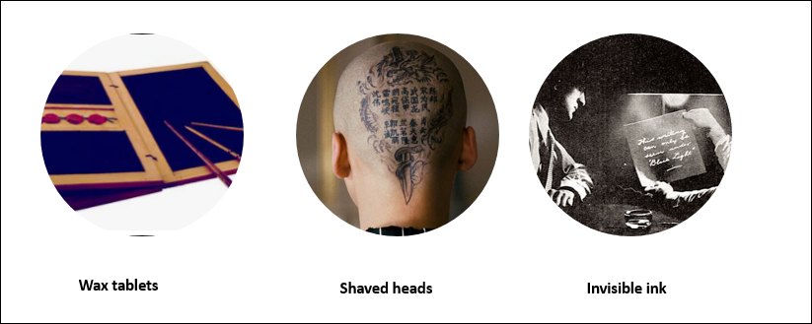

**What is cryptography?**

“Cryptography, or cryptology is the practice and study of techniques for secure communication in the presence of third parties called adversaries.” - Source Wikipedia

Application of cryptography:

* During World war II (allies vas. Germans)
* Transferring funds electronically
* Crypto currency and blockchain
* Storing user information in data bases
* **PLAINTEXT**: The message itself we want to encrypt
* **CIPHERTEXT**: Encrypted message
* **ENCRYPTION**: Process of encoding a given message in a way that only the authorized parties can access it
* **DECRYPTION**: Process of decoding a given message
* **KEY**: This is a sequence that is needed both for encryption and decryption

Cryptosystems use a set of procedures known as cryptographic algorithms, or ciphers, to encrypt and decrypt messages to secure communications among computer systems

**cipher_text =** **f(plain_text)** Encryption function

**plain_text = f-1(cipher_text)** Decryption function (which is inverse of encryption function)

Different cryptographic algorithms:

**Symmetric(private)-key algorithms**

1. Caesar cipher
2. Vigenere cipher
3. Data Encryption Standard (DES)
4. Advanced Encryption Standard (AES)
5. Blow fish

**Asymmetric(public)-key algorithms**

1. RSA (Ron Rivest, Adi Shamir, and Leonard Adleman)
2. ECC (Elliptic Curve Cryptography)

## 1.2 PROJECT SCOPE

The primary idea behind developing this project is to protect confidential data from an intruder’s counterattacks and to block the intruder through various levels in his/her attacks.   
A new tool has been developed with a combination of cryptographic and steganographic encryption for its implementation. The developed steganography tool has a sender’s segment that can take a message, a key and a cover image as input and give a stego-image as output that has message embedded in it. On the other hand, it also has a receiver’s segment where the receiver inputs the stego-image and the same key is used by the sender as input to get the sender’s message as output. This project is developed for hiding information in any image file. The scope of the project is implementation of steganography tools for hiding information includes any type of image.

## 1.3 DRAWBACKS OF EXISTING SYSTEM AND BENEFITS OF PROPOSED SYSTEM: -

The proposed technique will not alter or degrade the visual quality of the image after hiding the data in the image where are exiting techniques many of them embedding techniques can be broken or shows indication of alteration of image by careful analysis of the statistical properties of noise. Using a single cryptographic technique will make the system volatile so in the proposed system multiple encryption techniques are used to protect data

The proposed system has following benefits: -

1. Data or the information is very secure as the system includes not only imperceptibility but also un-delectability.
2. Protects data in multiple layers
3. Quality of image will not be degraded even after embedding the data
4. Larger amount of data can be stored in an image with high resolution.
5. User can access the older data with proper and secure authentication
6. Even the meta data (key, cover image) will be storied in the data in encrypted form after encryption
7. System will allow user to download the stego-image to communicate though other mediums.

## 1.4 DEFINITIONS, ACRONYMS, AND ABBREVIATIONS

* **Cover-Image**: Original image which is used as a carrier for hidden information.
* **Message:** Actual information which is used to hide into images. Message could be a plain text or some other image.
* **Stego-Image:** After embedding message into cover image is known as stego-image.
* **Plain text:** Unencrypted original information or data
* **Cipher text:** Encrypted form of plain text
* **Private key(Secret key**) : - Is a sequence of characters used in cryptographic algorithm to encode & decode data.

## PROJECT OVERVIEW

**Pixel and Bits:**

A digital image is a rectangular grid of pixels, or "picture elements" as illustrated in the below image. Digital images exist as an array of bytes in a computer's RAM memory or files as several popular file formats.

Each pixel typically consists of 8 bits (1 byte) for a Black and White (B&W) image or 24 bits (3 bytes) for a colour image-- one byte each for Red, Green, and Blue.

Every colour image is made up of pixels and every pixel contains 3-values (red, green, blue)

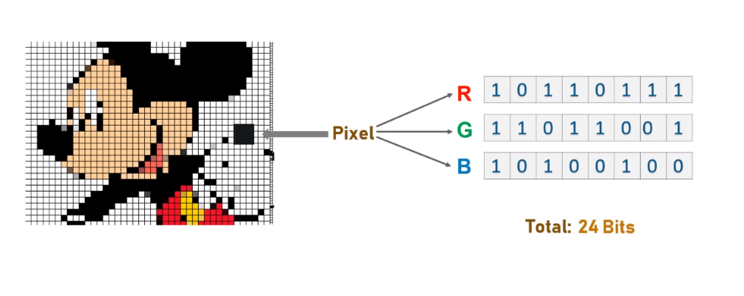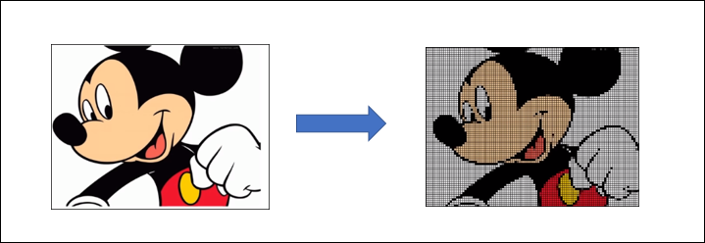

**RGB Model: -**

“The RGB colour model is an additive colour model in which red, green, and blue light are added together in various ways to reproduce a broad array of colours. The name of the model comes from the initials of the three-additive primary colours, red, green, and blue.” –source A picture containing diagram
Wikipedia

**LSB and MSB: -**

In a byte MSB is a bit of the highest digit, and the LSB is a bit of the lowest digit. like ordinary numerical notation, the left end is the highest digit, while the right end is the lowest digit. For example, 99 in the decimal system is expressed as (MSB)01100011(LSB) in the binary system. In this case, the MSB is 0 and the LSB is 1.

Percentage of effect on the overall value of a byte changing MSB or LSB is illustrated in below image

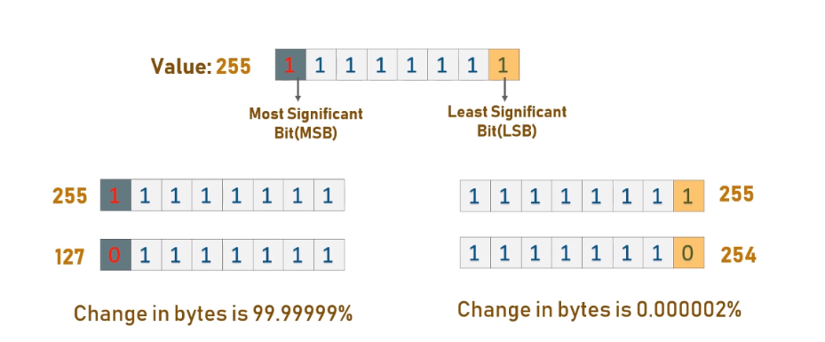

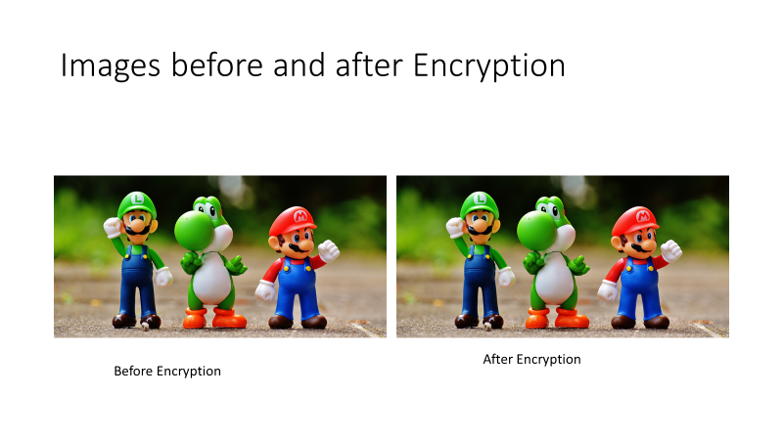

Following three properties should be satisfied by the stego image for a secure data communication

1. Transparency
2. Robustness
3. Tamper resistance

### **EMBEDDING PROCESS**

Embedding process involves hiding the bits of secret message in the LSB of RGB values of the pixel according to even odd distribution method.

RGB values of pixel which end with 1, will always have odd value.

And RGB values of pixel which end with 0 will have even value.

While embedding 0 value from secret bits to 0 value of pixel made it no change as shown in the below Figure, then the pixel stay the same without change in other hand embedding 1 of secret bit value to 0 of LSB pixel value made change in pixel value replace by one, also when embed 0 value of secret bit to 1 value the pixel replace by 0.

And embedding 0 value from secret bits to 0 value of pixel will also make no changes Therefore, the imperceptibility of method will increase.

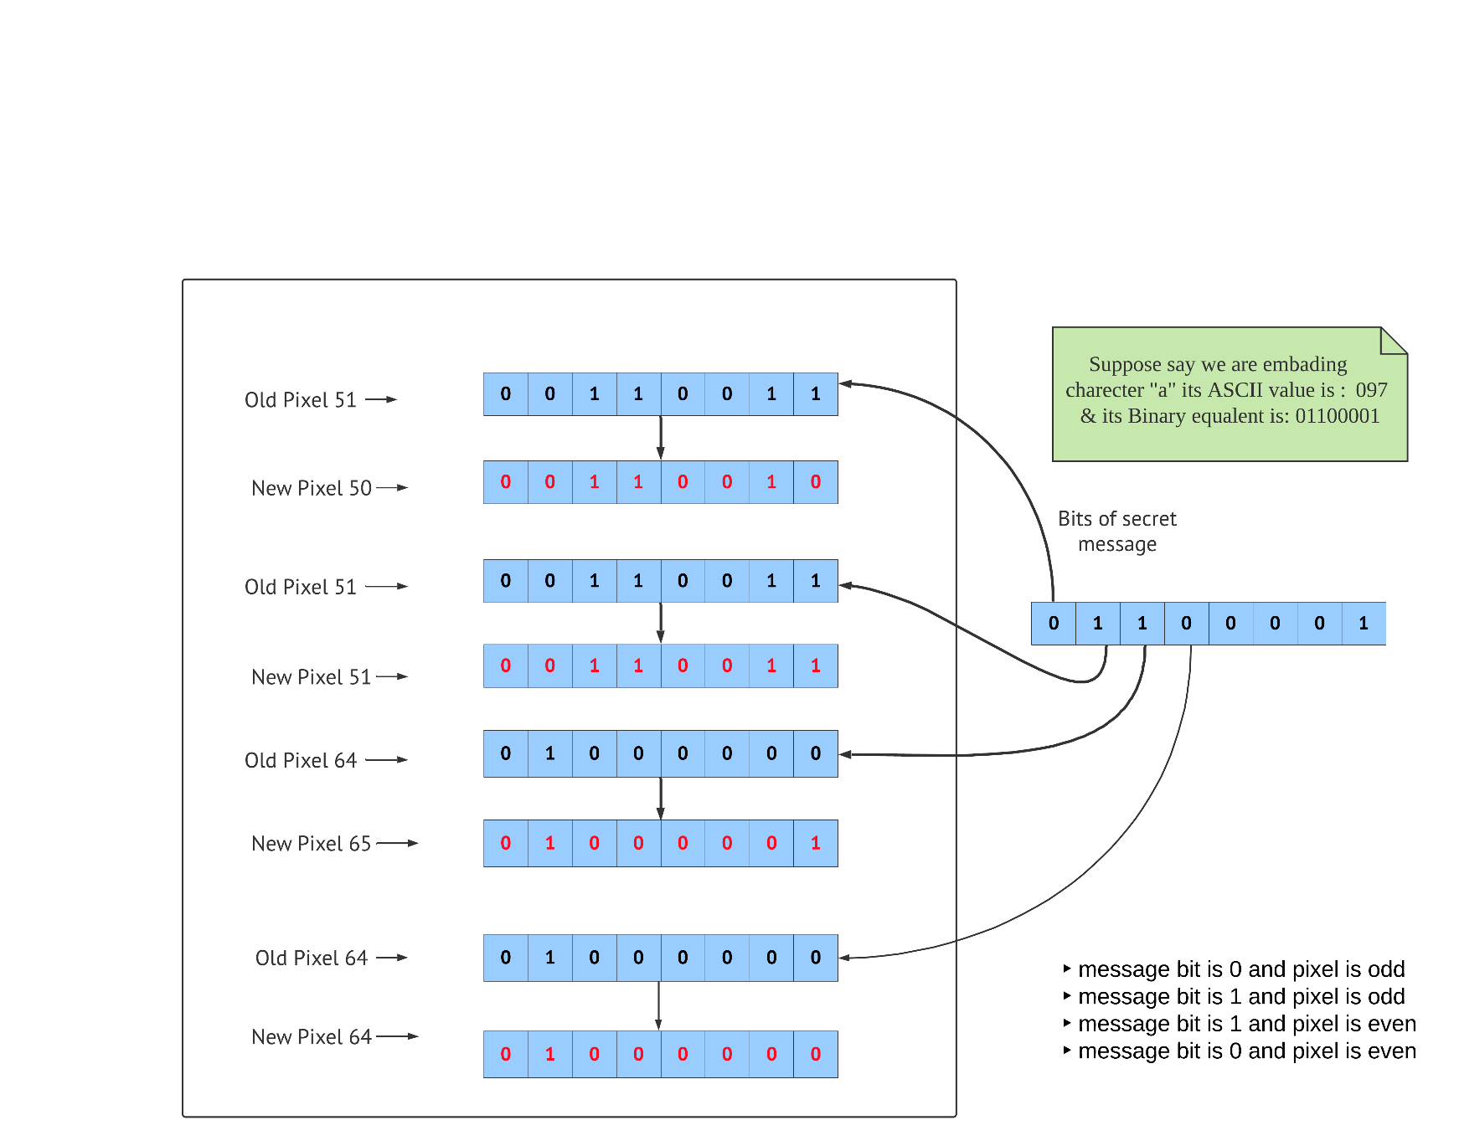Figure 1.5.1.

Suppose if we want to hide character ‘a’ in a cover image which has certain number of pixels.

Say R, G, B values for a 3 x 3 image with a total 9-pixels are

[(51, 51, 64), (64, 244, 174), (222, 12, 250), (78, 95, 77),(155, 22, 88), (6, 222, 88), (12, 173, 97), (78, 69, 255),(255, 29, 213)]

#ord('a') = 97 Unicode(ascii) value

The first 128 Unicode code point values are the same as ASCII

Change Unicode to 8 bits binary (‘08b’): - 01100001

Pixel values after insertion : [(50, 51, 65), (64, 244, 174), (222, 13, 250), (78, 95, 77),(155, 22, 88), (6, 222, 88), (12, 173, 97), (78, 69, 255), (255, 29, 213)]

### **1.5. 2 EMBEDDING ALGORITHM**

1. Get the Unicode (ascii) value of given char
2. changes Unicode to 8 bits binary
3. Calculate the size of the message (no. of character or byte)
4. Select a cover image
5. Extract and group 3 pixels each contain [R, G, B] values total of 9 values
6. Get message bit (0 or 1)
7. If secret message is 0 and pixel is even, do nothing
8. If secret message = 0 and pixel is odd, replace the value 1 by 0 of the LSB
9. If secret message is 1 and pixel is even, replace the value 0 by 1 the of the LSB
10. If message bit is 1 and pixel is odd, do nothing.
11. Make the last value each set as be even until the end of message to use as a delimiter
12. Return Stego Image.

### **EXTRACTING PROCESS**

To decode, same as encode read three pixels at a time, till the last value is odd, which means the message is over (0 means keep reading; 1 means message is ended)

Each of the 3-pixels contains the encoded binary data, which can be extracted by the same encoding logic.

# **LITARATURE REVIEW**

Steganography word is originated from Greek words Steganós (Covered), and Graptos (Writing) which literally means “cover writing”. It is the art and science of hiding information such its presence cannot be detected, and a communication is happening. A secret information is encoding in a manner such that the very existence of the information is concealed. Paired with existing communication methods, steganography can be used to carry out hidden exchanges. steganography systems use multimedia objects like image, audio, video etc. as cover media because people often transmit digital images over email or share them through other internet communication application.

In the current project we are making using image as a cover object which is known as image steganography. Generally, in this technique pixel intensities are used to hide the information

The main goal of this projects it to communicate securely in a completely undetectable manner and to avoid drawing suspicion to the transmission of a hider data.

Before hiding data into an image, we are protecting it by using multiple cryptographic technics that too in randomized manner based on the sensitivity, so data in protected in multiple layers from being attached. The main goal of this projects it to communicate securely in a completely undetectable manner

Different methods of image steganography.

SPATIAL DOMAIN METHODS

mage domain applies bit insertion and noise manipulation of a covered image

1. **Least Significant Bit: -** LSB is a simple , common faster method for hiding information on cover image in LSB’s of the digital pixels
2. **Gray Level Modification: -** Technique based on a mathematical function. This technique maps data by altering Gray levels of the pixels without embedding or hiding it and uses the conception of even and odd numbers in mapping the data in the cover image
3. **Pixel Value Differencing:** PVD is based on the difference between pixel values.
4. **Quantization Index Modulation: -** Quantization Index Modulation (QIM) technique is considered host interference rejection method

TRANSFORM DOMAIN TECHNIQUES

In transform domain steganography, embedding the secret requires transforming the image from the spatial domain to the frequency domain by using any of the transforms

1. Discrete Cosine Transformation
2. Discrete Wavelet Transformation
3. Singular Value Decomposition

The spatial domain techniques provide, high quality and high embedding capacity but these do not provide robustness. On the other hand, transform domain provide robustness while providing very less embedding capacity.

# **SYSTEM REQUIREMENT SPECIFICATION**

## **SOFTWARE REQUIREMENTS**

Programming Language : Python3  
Database : PostgreSQL  
Front end : HTML,CSS, JavaScript

Operating System : Windows 7(ultimate) or higher version / Mac OS

Software : Anaconda , Visual Studio Code (IDE)

Browser : Chrome, Firefox, IE, safari etc.

## **HARDWARE REQUIREMENTS**

Processor : Intel i3 Minimum

Hard Disk : 120GB

RAM : 4 GB and above for better speed

Interface : Mouse, Keyboard

# **SOFTWARE ENVIRONMENT**

## **PYTHON**

Python is a widely used high-level programming language for general-purpose programming, created by Guido van Rossum and first released in 1991.it is powerful programming language. It has efficient high-level data structures and a simple but effective approach to object-oriented programming. Python features a dynamic type system and automatic memory management and supports multiple programming paradigms, including object-oriented, imperative, functional programming, and procedural styles. It has a large and comprehensive standard library.

Python is derived from many other languages, including ABC, Modula-3, C, C++, Algol-68, Small Talk, and Unix shell and other scripting languages. Python is copyrighted. Like Perl, Python source code is now available under the GNU General Public License (GPL).

Python is designed to be highly readable. It uses English keywords frequently where as other languages use punctuation, and it has fewer syntactical constructions than other languages. The Python programming language is a high-level language that can be characterized by all of the following buzzwords:

* Python is interpreted.
* Python is Interactive.
* Python is Object-Oriented.
* Python is a Beginner's Language.

Following are important characteristics of Python Programming.

* It supports functional and structured programming methods as well as OOP.
* It can be used as a scripting language or can be compiled to byte-code for building large applications.
* It provides very high-level dynamic data types and supports dynamic type checking.
* It supports automatic garbage collection.
* It can be easily integrated with C, C++, COM, ActiveX, CORBA, and Java.

PYTHON LIBRARY AND EXTENSION MODULES

The standard Python library and other extension modules are almost as important for effective Python use as the language itself. The Python standard library supplies many well-designed, solid, 100 percent pure Python modules for convenient reuse. It includes modules for such tasks as representing data, string, text processing and image processing, interacting with the operating system and file system, and web programming. Because these modules are written in Python, they work on all platforms supported by Python.

Extension modules, from the standard library or from elsewhere, let Python code access functionality supplied by the underlying operating system or other software components such as graphical user interfaces (GUIs), databases, and networks. Extensions also afford maximal speed in computationally intensive tasks such as XML parsing and numeric array computations. Python allows to write special-purpose extension modules in lower-level languages to achieve maximum performance for small, computationally intensive parts that originally prototyped in Python. Python also can allow to use tools such as SWIG to wrap existing C/C++ libraries into Python extension modules. Finally, Python can be embedded in applications coded in other languages, exposing existing application functionality to Python scripts via dedicated Python extension modules.

## PYTHON MODULES USED IN THE PROJECT :-

### **PILLOW**

Pillow is a python package, its stands for “Python Imaging Library”. Which adds image processing capabilities to Python interpreter.

This library provides wide range of file format support, an efficient internal representation, and powerful image processing capabilities.

The core image library is designed for fast access to data stored in a few basic pixel formats.

Using image class in this library, we can load images from files, processing other images, or creating images from scratch.

If you use pip, you can install it with :: pip install pillow.

### **NUMPY MODULE**

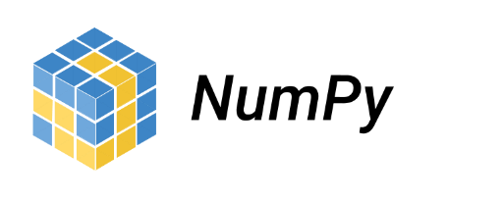  
NumPy is a Python package. It stands for 'Numerical Python'. It is a library consisting of multidimensional array objects and a collection of routines for processing of array. The following are some of key operations of NumPy.

* Mathematical and logical operations on arrays.
* Fourier transforms and routines for shape manipulation.
* Operations related to linear algebra. NumPy has in-built functions for linear algebra and random number generation.

If you use pip, you can install it with: pip install numpy.

## **DJANGO FRAMEWORK**

Framework is a combination of components and packages Django is a high-level Python-based free and open-source web framework, which follows the model-view-template (MVT) architectural pattern. It is maintained by the Django Software Foundation (DSF). Django's primary goal is to ease the creation of complex, database-driven websites. Some well-known sites that use Django includes : The Public Broadcasting Service, Instagram, Mozilla, The Washington Times.

If you use pip, you can install it with: pip install Django-admin.

Figure 4.3.1.1   
Model-View-Template (MVT) architecture of Django

### **4.3.1 Django ORM**

“The Django web framework includes a default object-relational mapping layer (ORM) that can be used to interact with application data from various relational databases such as SQLite, PostgreSQL and MySQL.” –source *full stack python*Data base tables and columns will be created based on the properties for the defined classes.

Java hibernate will also use ORM  
Django's query sets will be protected from SQL injection since their queries are constructed using query parameterization. A query's SQL code is defined separately from the query's parameters

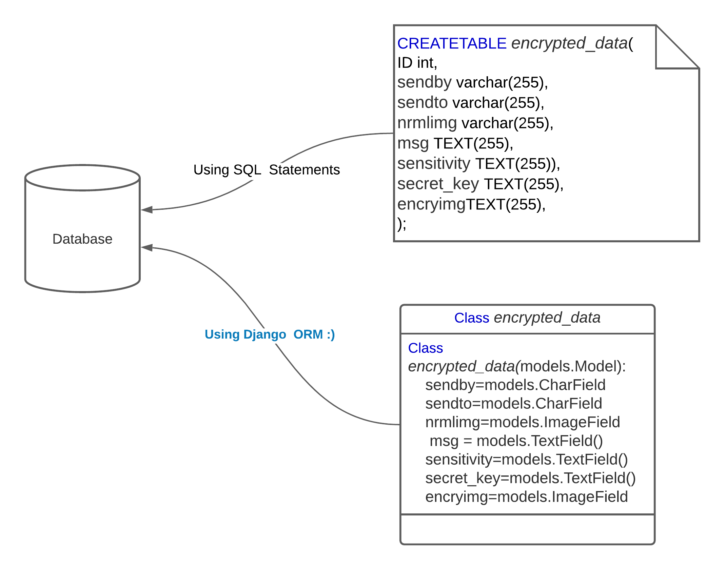

Figure 4.3.1.2

# **SYSTEM DESIGN**

## SYSTEM ARCHITECTURE

Figure 5.1 Show the entire proposed architecture of the project.

Figure 5.1

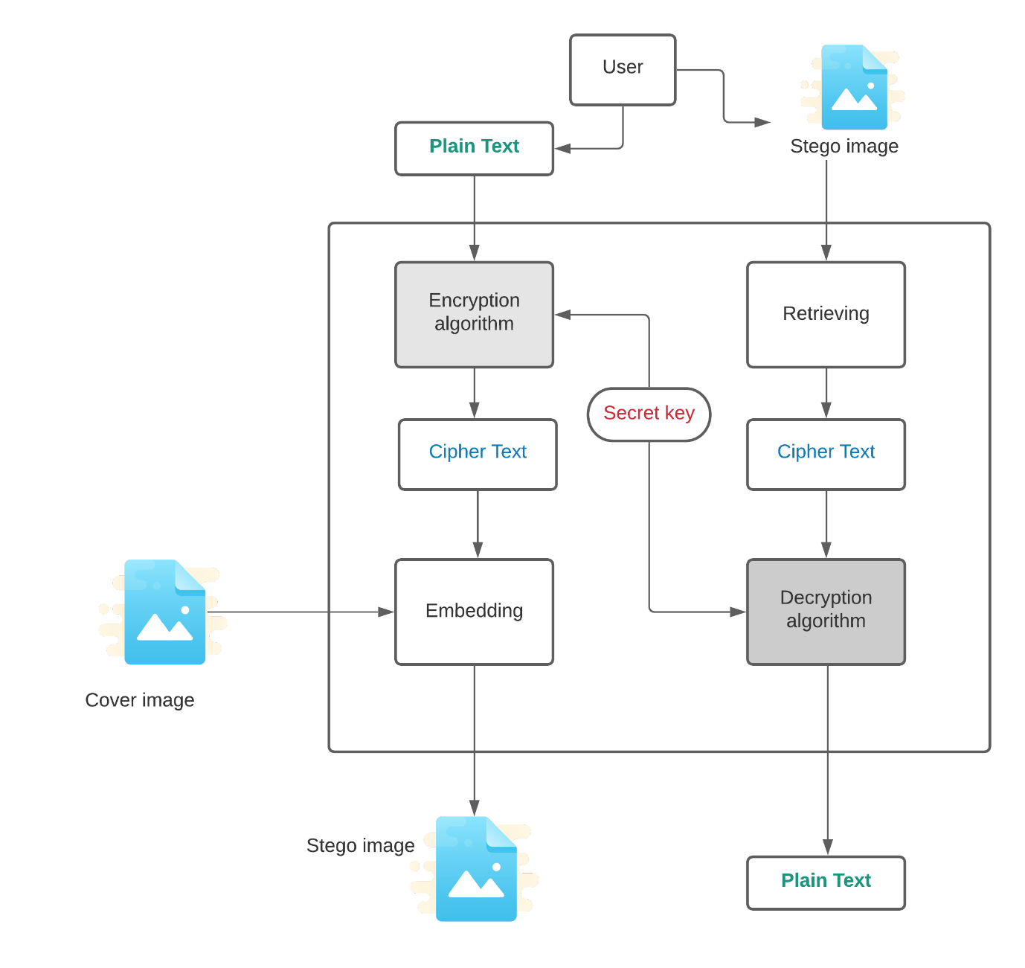

## UML DIAGRAMS

The Unified Modelling Language is a standard language for specifying, process analysis and design, visualization, constructing and documenting the artefacts of software system, as well as for business modelling and other non-software systems.

The UML represents a collection of best engineering practices that have proven successful in the modelling of large and complex systems. UML uses mostly graphical notations to express the design of software projects for better understanding.

Below are different UML diagrams

### **5.2.1 USE CASE DIAGRAM**

Below use case diagram illustrating how user can interact with the application.

**Actors**: The users that interact with a system. An actor can be a person, an organization, or an outside system that interacts with your application (User)

**Use Case:** Use cases describe the interactions that take place between actors and IT systems during the execution of business processes (Login, Registration, encrypt, decrypt, logout)

**Different Relations: -**

1. Association relationships.
2. Generalization relationships
3. Include relationships
4. Extend relationships

Figure 5.2.1

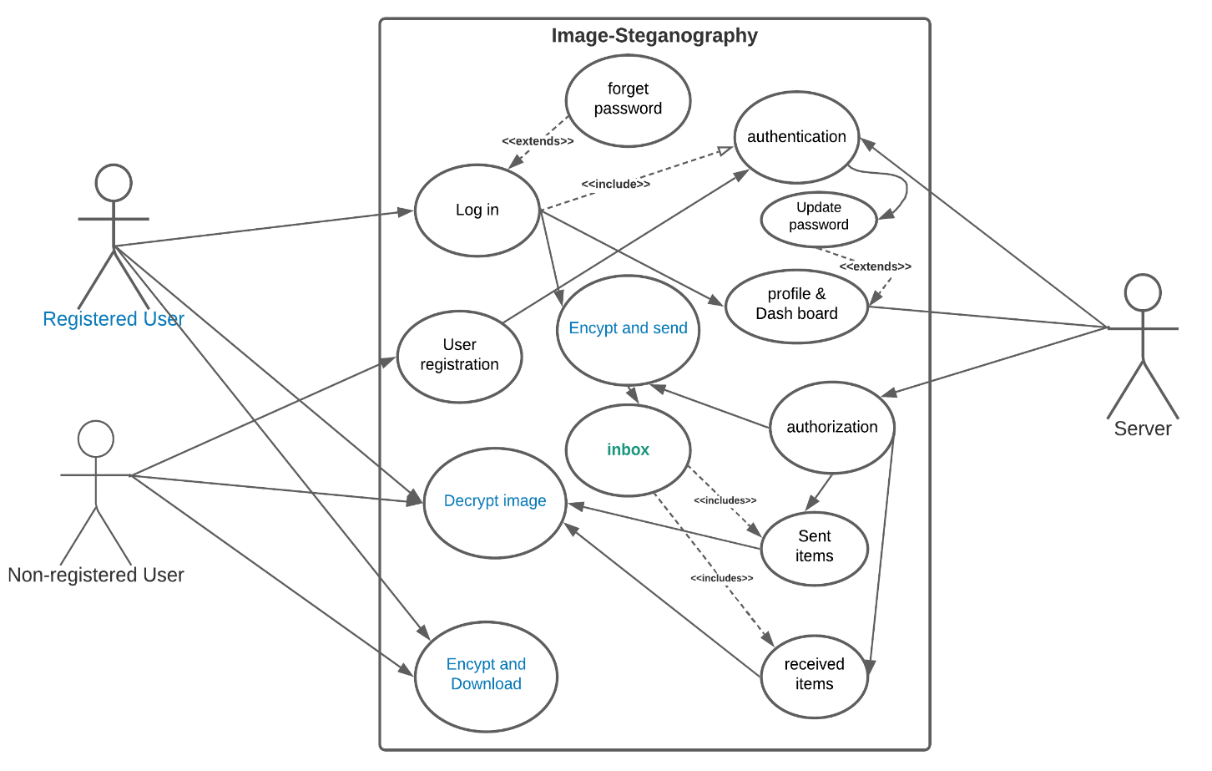

### **5.2.2 CLASS DIAGRAM**

Class diagram describes the structure of a system by showing the system's classes, their attributes, operations (or methods), and the relationships among objects.

Figure 5.2.2.1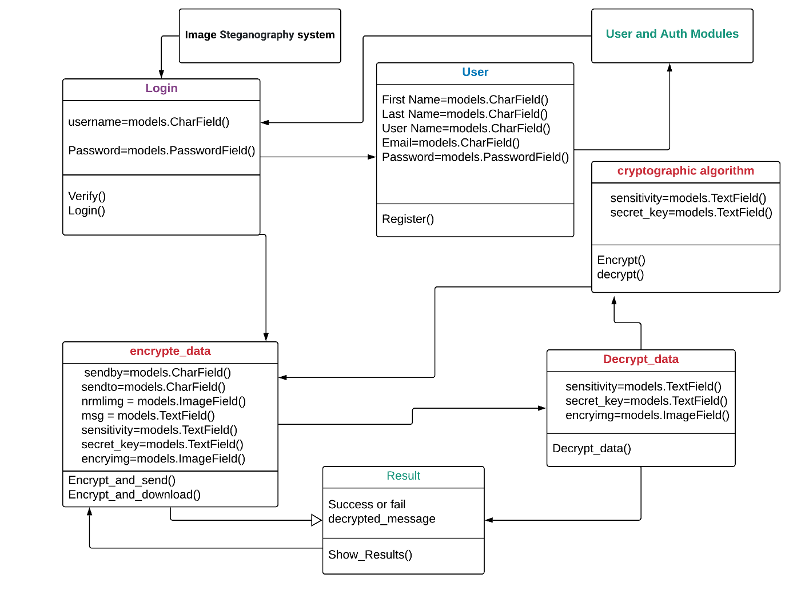

### **5.2.3 SEQUENCE DIAGRAM**

A sequence diagram is a type of interaction diagram. Which describes how and in what order group of objects works together.

Below are the parts of a sequence diagram

1. Activation box

2. Actor

3. Lifeline

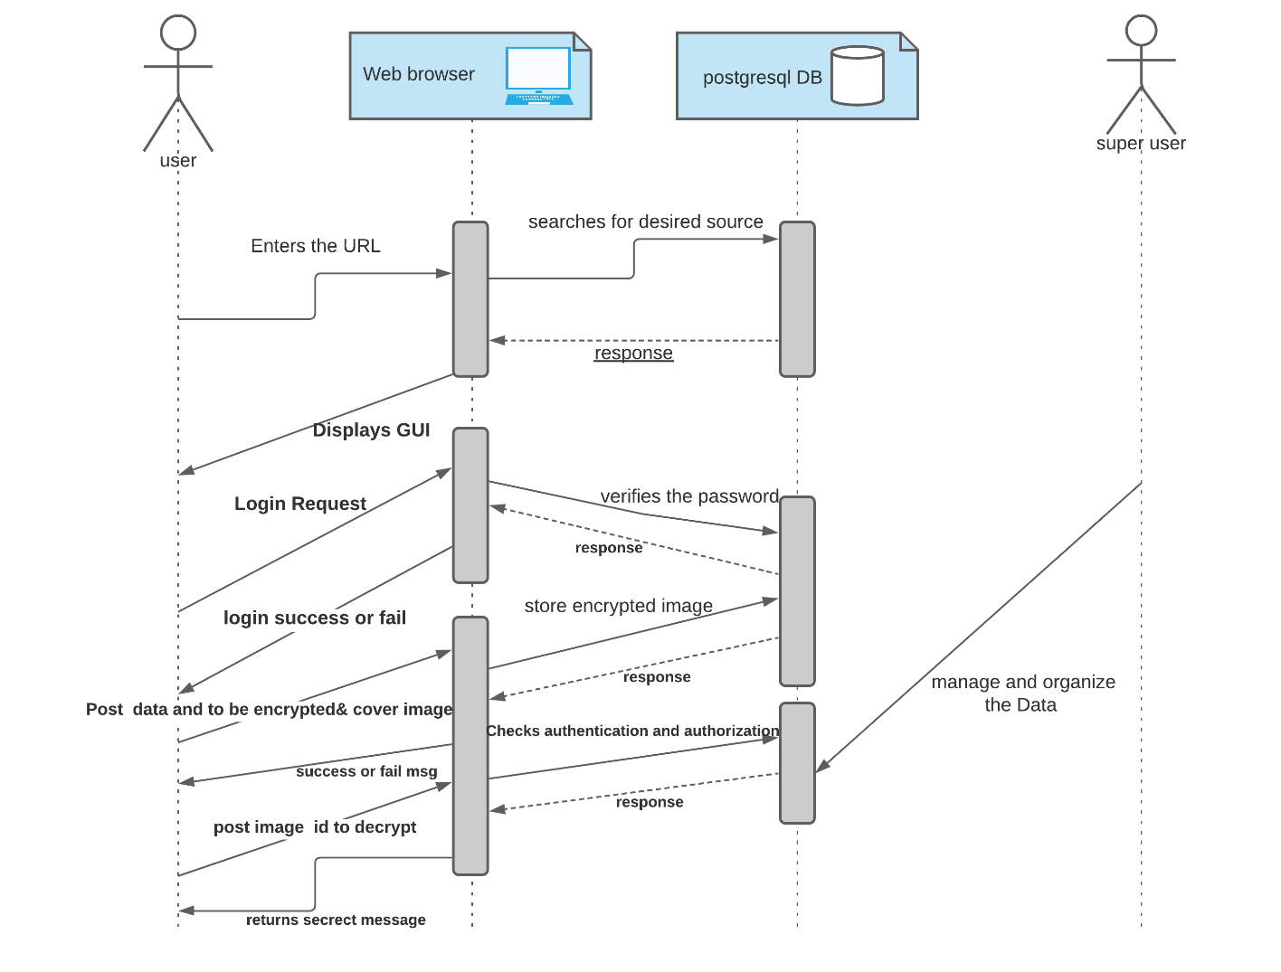

Figure 5.2.3.1

### **5.2.4 DATA FLOW DIAGRAM**

Data flow diagrams are used to graphically represent the flow of data in a business information system

Below are the parts of a data flow diagram

1. Process
2. External entity
3. Data store

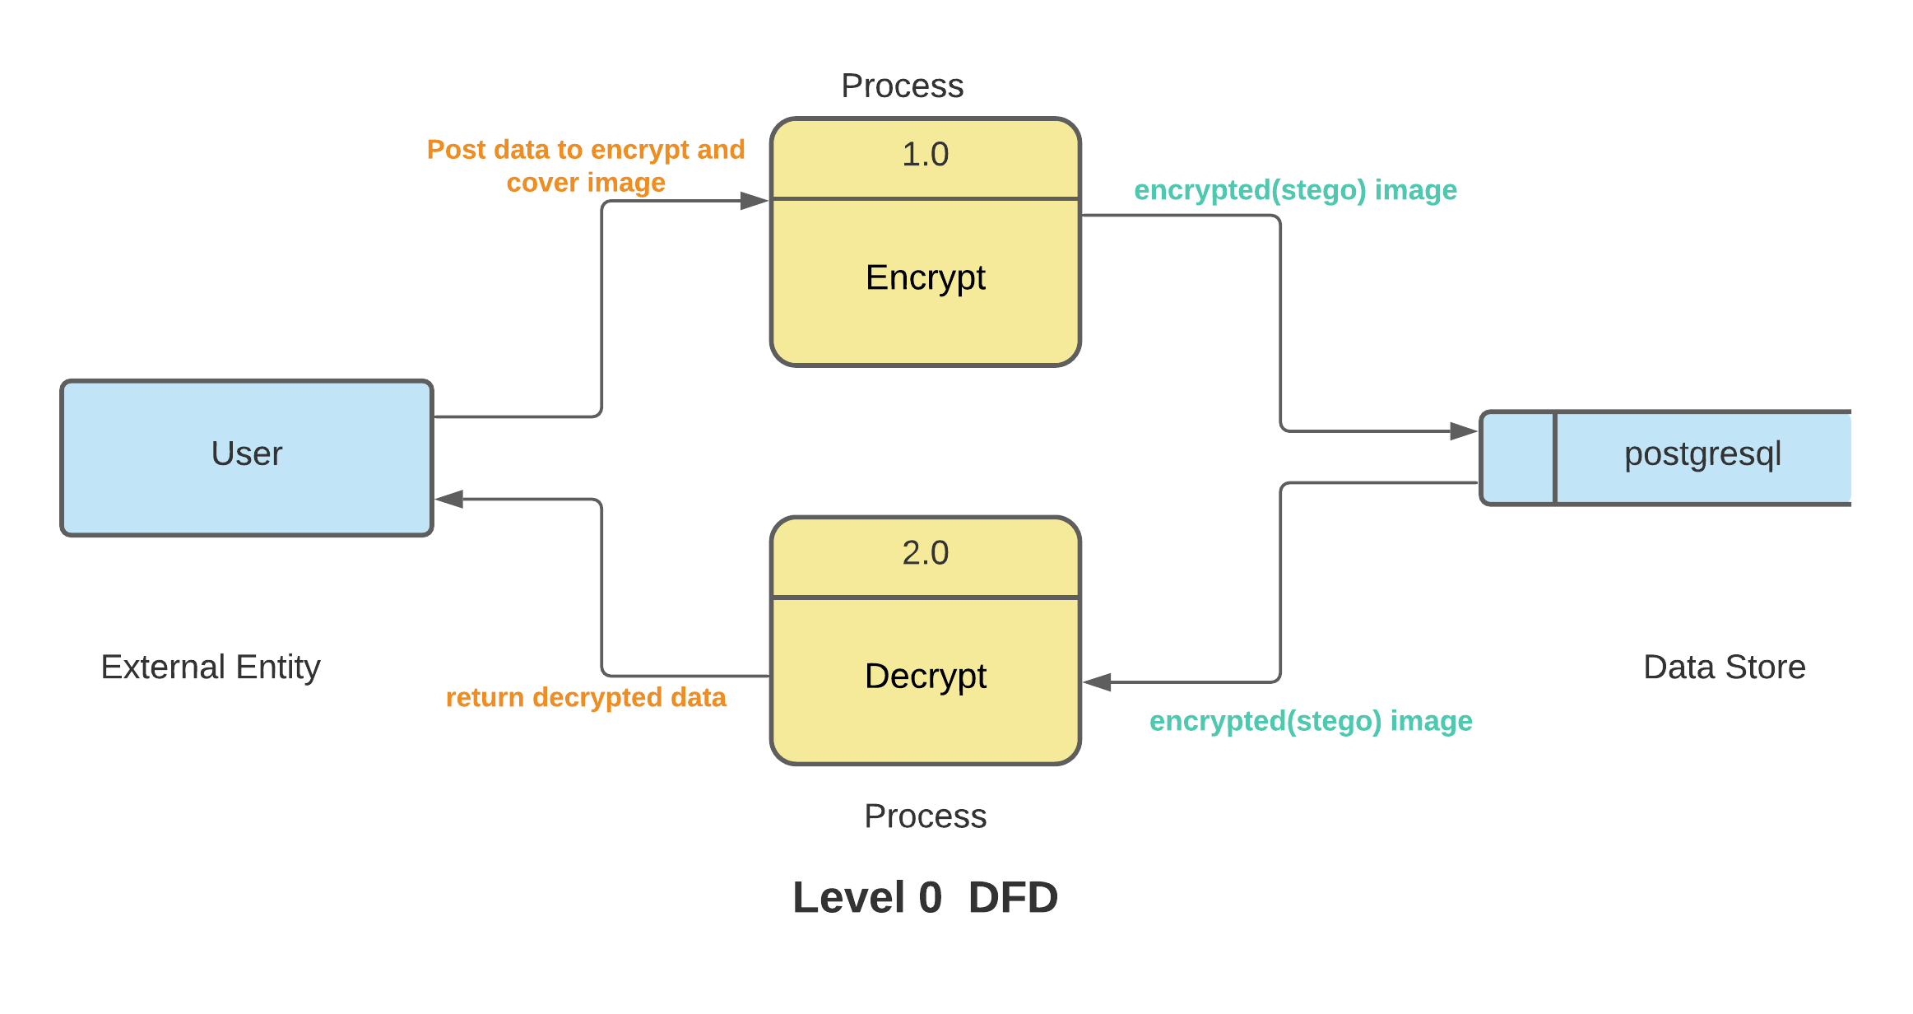

Figure 5.2.4.1

# **6.** **CONCLUSION AND FUTURE SCOPE**

## 6.1 CONCLUSION

Proposed steganographic technique based on LSB (Least Significant Bit) according to the odd/even distribution scheme is a “spatial domain technique”.

The spatial domain techniques provide, high quality and high embedding capacity but these do not provide robustness. On the other hand, transform domain provide robustness while providing very less embedding capacity,

Security of secret data is maintained using symmetric cryptographic techniques. Manipulating secret message before embedding help to increase the security of the scheme

Proposed system does not allow revealing secret data to intruder. Two main things make the system effective and secure are: first, checking matching of secret bits with LSB. second, is using advanced symmetric cryptographic techniques.

The embedding capacity of “Transform domain methods” steganography is very less than “spatial domain techniques”.

## 6.2 FUTURE SCOPE

“Spatial domain techniques” are easy ways to embed information, but they are highly vulnerable to even small cover modifications. Hence the size of stego-image cannot be reduced. An attacker can destroy the secret information entirely by applying image processing techniques. using “Transform domain methods” which hides messages in significant areas of the cover image which makes them more robust to attacks.

The cryptography techniques like DES, AES are secure, but sender and receiver must exchange the secret key. So, by using public key cryptographic techniques like RSA, ECC with steganography to provide more security.

# **7. REFERENCES**

1. Use Udemy to learn basics of python and machine learning   
   http://wipro.udemy.com/
2. Software design specification using   
   https://lucid.app/documents
3. Django documentation   
   https://docs.djangoproject.com/
4. Learning Python Book by David Ascher
5. Image Source  
   https://www.pexels.com/
6. Bootstrap for front end design  
   <https://getbootstrap.com/docs/5.0>
7. Python 3 documentation   
   <https://docs.python.org/3/>
8. Stack Overflow for implementation doubts or error  
   <https://stackoverflow.com/>